MINOR PROJECT

JAYPEE INSTITUTE OF INFORMATION TECHNOLOGY


“Stock Market Predictor”

SUBMITTED BY:
CHETANDEEP SINGH PAHUJA (12104714)
SHANTANU RAI (12104715)
RAJAT TYAGI (12104732)
(BATCH-B12)

Abstract:

Stock markets are a risky but highly profitable way of making money. For years traders have tried to make use of information to try and predict the trends that can occur in a market. Artificial neural networks help in such prediction. It’s uses for classification, pattern recognition and forecasting in the field of financial transaction is increasing.
This project aims to predict stock market values on a day to day basis using a feed forward neural network.

Introduction:
Neural networks are statistical learning models in machine learning and are used to estimate or approximate that depends on large input area. One such area is finance. Financial analyst results in second largest contributor to neural network research. In practice, many organizations have expressed interest in applying neural network technology. Stock market prediction is the act of trying to determine the future value of a company stock or other financial instrument traded on an exchange. The successful prediction of a stock's future price could yield significant profit. The efficient-market hypothesis suggests that stock price movements are governed by the random walk hypothesis and thus are inherently unpredictable. Others disagree and those with this viewpoint possess myriad methods and technologies which purportedly allow them to gain future price information. With the advent of the digital computer, stock market prediction has since moved into the technological realm. The most prominent technique involves the use of artificial neural networks (ANNs) and Genetic Algorithms. ANNs can be thought of as mathematical function approximators. The use of ANN simulates how human brain functions, by feeding computers with massive data to mimic human thinking. The most common form of ANN in use for stock market prediction is the feed forward network utilising the backward propagation of errors algorithm to update the network weights.

Technical analysis:
Backpropagation neural networks consist of a collection of inputs and processing layer known as neurons, neurodes or nodes. The neurons in each layer are fully interconnected by connection strengths called weights which, along with network architecture, store the knowledge of a trained network. In addition to each processing unit in hidden and output layers. The bias neuron has a value of positive one and serves a similar purpose as the intercept in regression models. The neurons and bias terms are arranged into layers; an input layer, one or more hidden layers, and an output layer. The number of hidden layers and neurons within each layer can vary depending on the size and nature of the data set.
BackPropagation networks are a class of feed forward neural networks with supervised learning rules. Feedforward refers to the direction of information flow from the input to the output layer. Inputs are passed through the neural networks once to determine the output. Supervised learning is the process of comparing each of the network’s forecasts with the known correct answer and adjusting the weights based on the resulting forecast error to minimize the error function.
The network is trained using a gradient descent algorithm with a learning rate of 0.01.
The algorithm follows the contours of the error surface by always moving down the steepest slope with an objective to minimize the average root mean square error as follows
Neural Networks are similar to linear and non-linear least squares regression and can be viewed as an alternative statistical approach to solving the least squares problem. Both neural networks and conventional regression analysis attempt to minimize the sum squared errors. The bias term is analogous to the intercept term in regression equation. The number of input neurons is equal to the number of independent variables while the output neuron(s) represent the dependent variable(s). the weights connecting the input neurons to the single output neuron are analogous to the coefficients in a linear least squares regression. Networks with one hidden layer resemble nonlinear regression models. The weights represent regression curve parameters.

Steps in designing a neural network forecasting model:
Step 1: data collection
Step 2: data pre-processing.
Step 3: Feature selection
Step 4 :Neural network paradigms
Number of hidden layers
Number of hidden neurons
Number of output neurons
Transfer functions
Step 5: Training, testing and validation sets
Step 6: Evaluation critera
Step 7:Implementation

Step 1 :Data Collection
When collecting data one should consider cost and availability. Technical data is easily available from many vendors at a reasonable cost. We got the data on stocks from yahoo finance and exchange rates from forex.

Step 2: Data pre-processing
Data pre-processing refers to analysing and transforming the input and output variables to minimize noise, highlight important relationships, detect trends and flatten distribution of variables to assist the neural network in learning the relevant patterns. Since neural networks are pattern matchers, the representation of the data is critical in designing a successful network.
The steps followed during data pre-processing stage are:
- Scaling the input and output variables in the range [0,1]
- Normalizing the values w.r.t its mean and standard deviation.
Scaling the input and output variables is especially important to ensure that our network converges properly , since we have used a sigmoid activation function for each neuron inputs in an arbitrary range may cause the network to diverge as the number of epochs increase.
Normalizing the values ensures that our data is distributed across all neurons otherwise the output activation may depend heavily upon the activation of a single or only a few neurons in the hidden layer.
The above graphs show how mean normalization can affect the distribution of data.

Step 3: Feature selection
Success is designing a neural network depends on a clear understanding of the problem [2].While even simple neural networks can map complex functions their efficiency depends heavily on the input data provided to it.
Knowing which input variables are important in the market being forecasted is critical.
Most researchers have used various economic indicators such as moving averages , price earnings ratios, etc. to model short term non linearity we propose a hypothesis that the price of a stock can be estimated to a high degree using only numeric indicators such as opening and closing prices of stocks, currency exchange rates and market indices.

For this reason features are selected on the basis of correlation with the stock price. The features that affect the stock price of adobe systems are shown below.
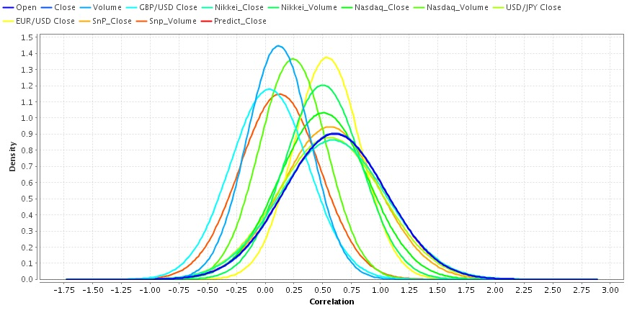
The correlation density for each feature w.r.t the closing price of a share.

For apple shares the correlation of closing price w.r.t to a feature is as follows:
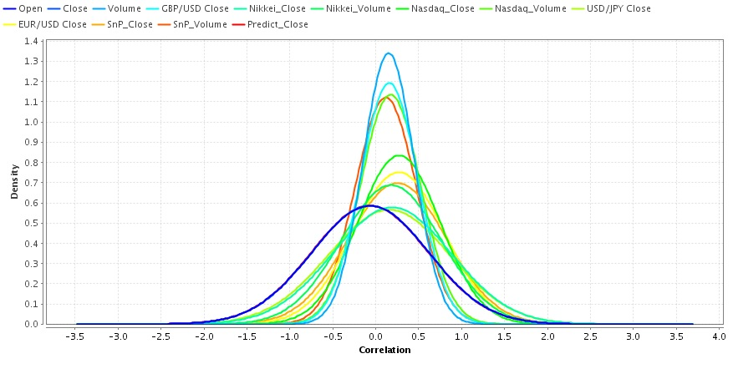
Clearly we can see that for any given stock these features affect share prices the most. Hence they have been chosen as input variables in our neural network.

Step 4: neural networks paradigm.
- Number of hidden layers.
Each neuron computes a linear transformation of its input variables. Having hidden layers in our network enbale it to recognize non linear functions . generally two hiden layers can be used to compute an aproximation of any existing function . however ,for this network we will be using only one hidden layer since it provides a high degree of accuracy while being able to map significantly complex mathematical realations.

- Number of hidden neurons
There does not exist any scientific method to estimate the number of hidden neurons that should be used . usually the number of neurons tha shold be used is estimated through a trial and error process that do however exist a few rule of thumb. One of these suggest that the optimal number of hidden neurons usually lies between 75% to 300% of the number of input neurons.
Incraesing the number of neurons does enable the network to model more complex functions bt at the same time it reduces the networks’ degrees of freedom increasing the risk of overfitting. To counter this attenton has to be paid to cross validation performance of the network.
For our network we have observed that having 12 neurons usually gives the best results.

- Number of output neurons
Only one output neuron is required since we only aim to predict the stock price of the share.

- Transfer functions
Properly chosen transfer functions are essential if we want to map non linearity in our data . since our robem is a regression problem we have chosen linear tarnsfer functions for our output layer along with a sigmoid transfer function in our input layer to model non linearity. A bias has also been added to our input and hidden layers to enable the sigmoid curve to shift.

Step 5: Training, testing and validation sets
We collected input data for each feature in the period. 1st april 2012 to 31st march 2015.The first two years of data was used in training and validation. While the last year of data was used for prediction.
During the training phase our objective was to find a set of weights that minimize the root mean square error between the predicted and actual values. The algorithm used for this purpose was gradient descent algorithm with a learning rate of 0.03 and no momentum
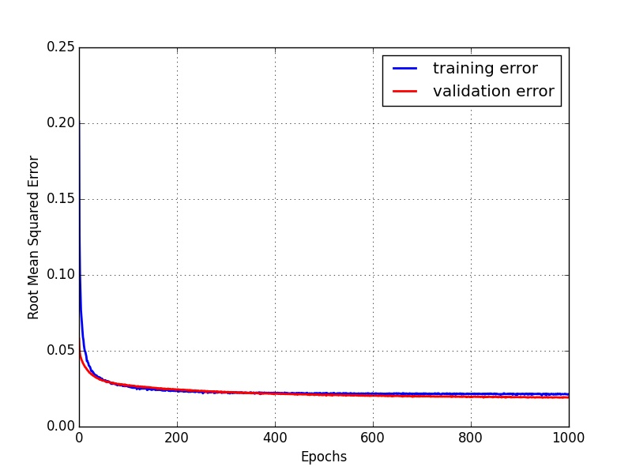
Root mean squared error v/s epochs for the training and validation cycles for adobe systems
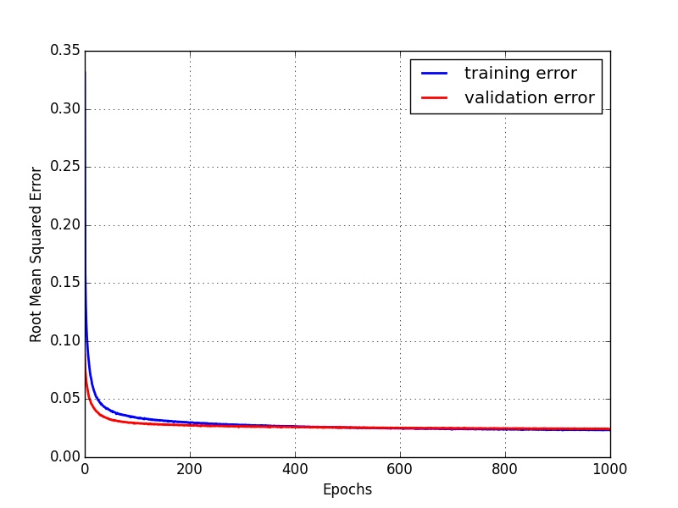
Root mean squared error v/s epochs for the training and validation cycles for apple Inc.

The graphs above show that the gradient descent starts to converge at around 800 epochs hence 1000 training cycles was deemed appropriate to train the network.

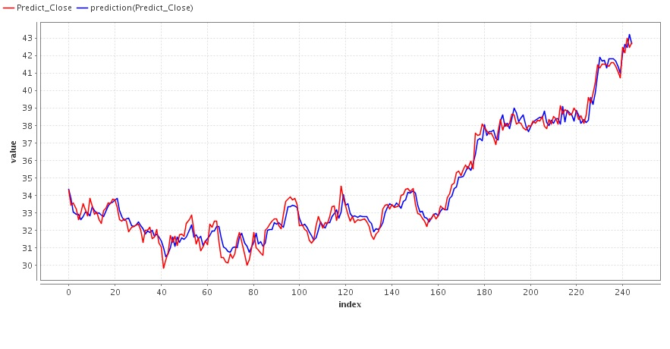
Function approximated by the network on the training dataset of adobe systems

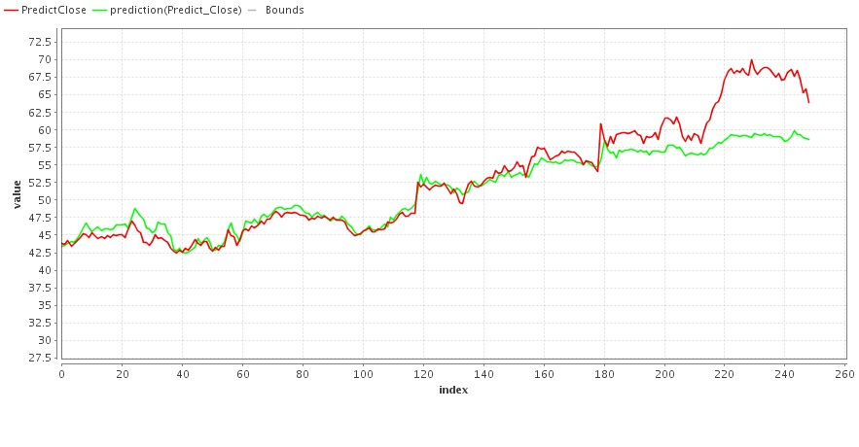
Function approximated by the network on the validation dataset of adobe systems

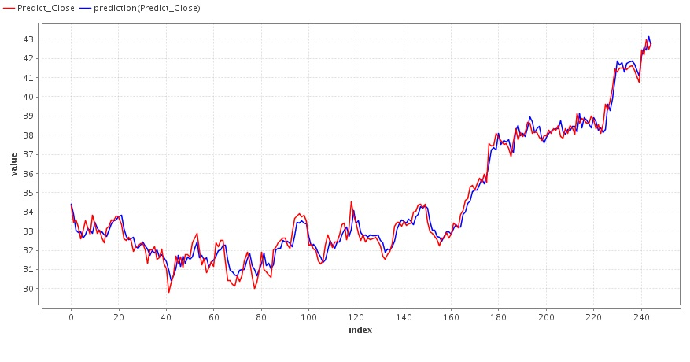
Function approximated by the network on the training dataset of apple Inc.

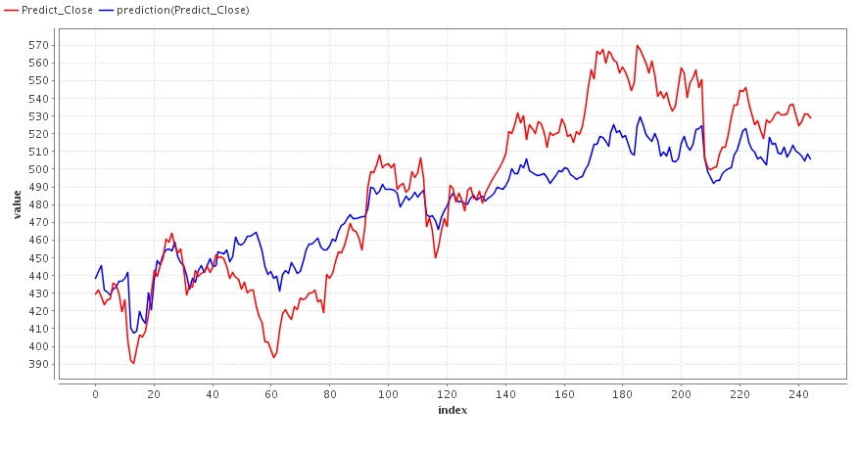
Function approximated by the network on the validation dataset of apple Inc.

Step 6: Evaluation critera
Since a time series analysis is being done the evaluation criteria is based on two factors .
Factor 1- average root mean squared error.
Factor2- Correlation with the target series.
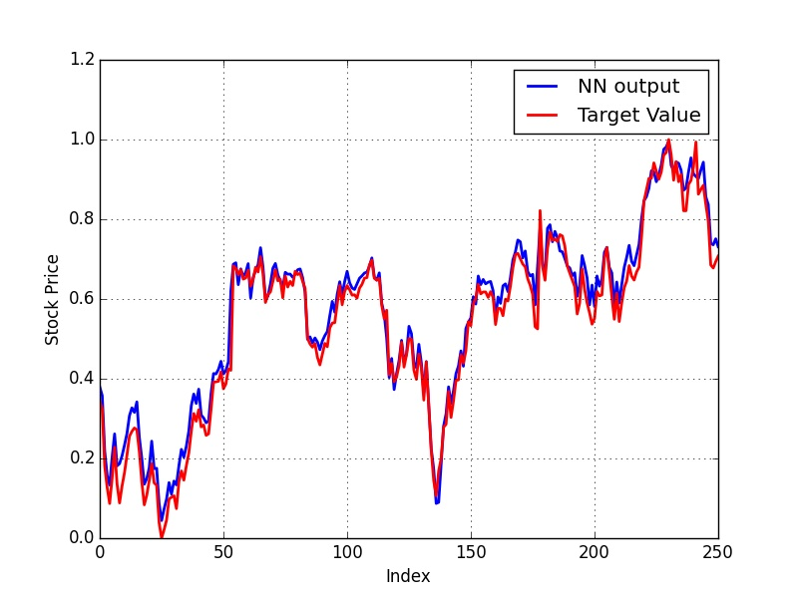
Normalized output for adobe stocks 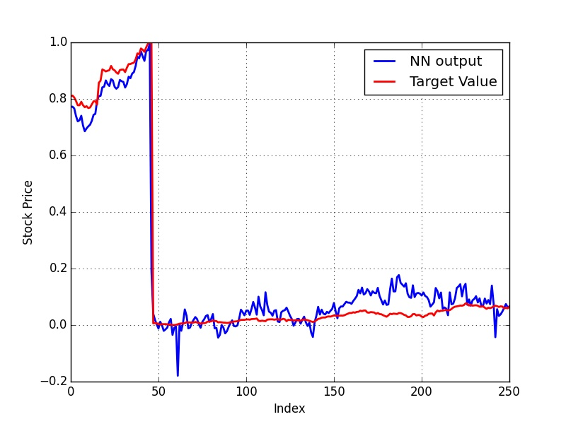
Normalized output for apple stocks

Accuracy:
Adobe system:
Root mean squared error= 3.711
Correlation coefficient =0.913

Apple Inc.:
Root mean squared error= 222.886
Correlation coefficient =0.991

Step 7:Implementation
The neural network has been implemented in python with several machine learning packages such as Numpy and scikit being used to assist in the data transformation and pre-processing stages.

Future work
As we have seen even a simple field forward neural network is extremely powerful when it comes to predicting a time series however the prediction data for apple Inc. during the time 1st April 2014 to 31st March 2015 highlights an important vulnerability in this approach . The sudden decline in apple shares caused by its splitting could not be predicted by the network in fact decline of this scale affected its prediction accuracy for the entire year as you can see that even though it follows the target curve very closely it has a very high root mean squared error. The effect of such “black swan “ events may be mitigated to a certain extent through the use of recurrent neural networks. Such networks have already shown much promise in areas such as image classification and handwriting recognition. And their ability to possess memory might give them a significant advantage over simple field forward networks when it comes to time series forecasting

References
- A New Computational Method of Input Selection
for Stock Market Forecasting with Neural Networks
Wei Huang , Shouyang Wang , Lean Yu , Yukun Bao , and Lin Wang
School of Management, Huazhong University of Science and Technology,
WuHan, 430074, China
ICCS 2006,
- Designing a neural network for forecasting financial and economic time series
Iebeling Kaastra, Milton Boyd
23rd March 1995
- Neural Network Predictions of Stock Price Fluctuations
Wojciech Gryc
2006

